HAND OUT PREPARED AND PRESENTED BY

COMRADE DR. LEKE SUCCESS, JP

TOPIC: MANAGING PRE AND POST RETIREMENT STRESS

THEME: EVALUATING TRADE UNION ROLES IN MANAGING EMPLOYEES GRIEVANCE AND GRIEVANCE PROCEDURES: THE HOSPITALITY AND CATERING INDUSTRY EXPERIENCE

VENUE: LAGOS AIRPORT HOTEL, LAGOS

DATE: 17TH – 19TH JULY, 2024

ORGANIZED BY

NATIONAL UNION OF HOTELS AND PERSONAL SERVICES WORKERS (NUHPSW)

# MANAGING PRE AND POST RETIREMENT STRESS

**WHAT IS STRESS?**

Stress is the natural reaction your body has when changes or challenges occurs. It can result in many different physical, emotional and behavioral responses. Everyone experiences stress from time to time. You can’t avoid it. But stress managementtechniquescanhelpyoudealwithit.Stressisanaturalreactionthat happens to every one. In fact, your body is designed to experience stress and react to it. When you experience changes or challenges (stressors), your body produces physical and mental responses; that’s stress.

Stress responses help your body adjust to new situations. Stress can be positive- keeping you alert, motivated and ready to avoid danger. For example, if you have an important test coming up, a stress response might help your body work harder and stay awake longer. But stress becomes a problem when stressors continue without relief or period of relaxation.

# TYPES OF STRESS

There are three main kinds of stress; acute, episodicacute and chronic.

1. ***Acute Stress***: Acute stress is a short term stress that comes and goes quickly. It can be positive or negative. It’s the feeling you get when you are riding a rollercoaster or having a fight with your boyfriend/husband. Everyone experiences acute stress from time to time.
2. ***Episodic Acute Stress:*** Episodic acute stress is when you experience acute stress on a regular basis. With this kind of stress, you don’t ever get the time you need to return to calm, relaxed state. Episodic stress frequently affects people working in certain professions, like health care providers.
3. ***Chronic Stress:*** Chronic stress is long-term stress that goes on for weeks or months.Youmayexperiencechronicstressduetomarriagetroubles,issues at work or financial problems. It’s import to find ways to manage chronic stress because it can lead to health issues.

# SYMPTOMS AND CAUSES

### How does stress affect the body?

When you have long-term (chronic) stress, continue activation of the stress response causes wear and tear in your body. You may develop symptoms that are physical, psychological or behavioral.

# IMAGES BELOW SHOW THE PHYSICAL AND EMOTIONAL SYMPTOMS OF STRESS

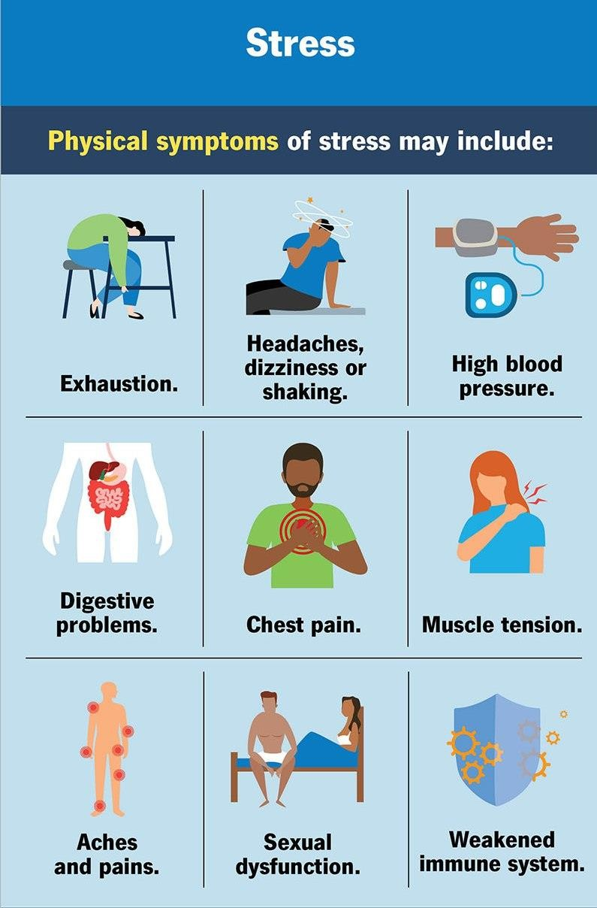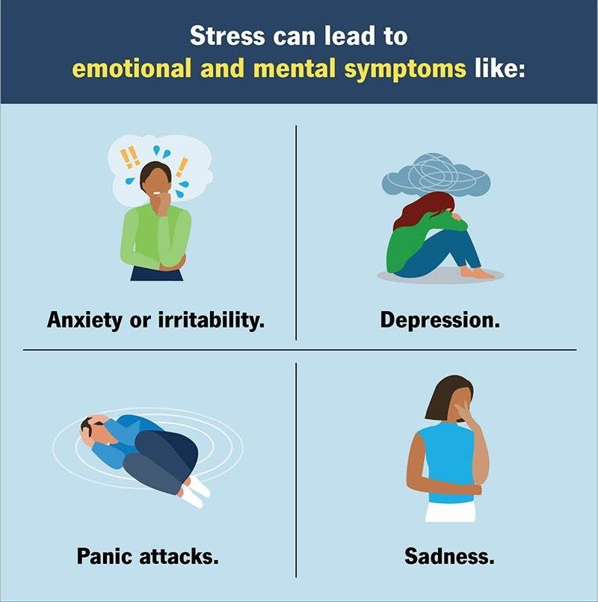

**PHYSICAL SYMPTOMS**

Physical symptoms of stress may include:

* Aches and pains
* Chest pain or a feeling like your heart is racing
* Exhaustion or trouble sleeping
* Headache, dizziness or shaking
* High blood pressure(hypertension)
* Muscle tension or jaw clenching
* Stomach or digestive problems
* Trouble having sex.
* Weakened immune system

# PSYCHOLOGICAL SYMPTOMS

Stress can lead to emotional and mental(psychological)symptoms, like:

* Anxiety or irritability
* Depression
* Panic attack
* Sadness

# BEHAVIORAL SYMPTOMS

Often, people with chronic stress try different things to cope. And some of those things are habit-forming and can have impact on your health. These may include:

* Alcohol use disorder
* Gambling disorder
* Overtaking or developing an eating disorder
* Participating compulsive in sex, shopping or Internet browsing
* Smoking
* Substance use disorder

# WHAT CAUSES STRESS?

* An illness or death of a loved one
* Marriage, separation or divorce
* Financial issues
* Moving to a new house
* Going on vacation
* Having baby
* Retiring
* Losing a job

Stress can also be acute, meaning short-term.

### Cause of acute stress may include everyday challenges, like;

* Having an argument with a friend or loved one.
* Needing to get a lot completed in a short amount of time.
* Experiencing small problems all at once, like getting in a traffic jam, spilling coffee all over yourself and running late
* Studying for a big test
* Getting ready for work presentation

# WHAT ARE THE COMPLICATIONS OF STRESS?

Chronic stress can lead to many long-term health issues affecting your;

* Immune system(like arthritis, fibromyalgia and psoriasis)
* Digestive system(e.g. weight loss or gain, ulcers, and irritable bowel syndrome)
* Cardiovascular system (like high blood pressure, increased heart rate, and heart palpitations)
* Reproductive system(e.g. infection, polycystic ovarian syndrome and infertility)

Stress can also put you at a higher risk of developing mental health condition, like depression or anxiety. If you are feeling severely stressed and thinking about hurting yourself, please call your friend or love one to reach out to suicide and crises lifeline.

### ADJUSTING TO RETIREMENT

Handling depression, stress and anxiety while retiring can be are ward for years of work; it can also trigger stress, anxiety, and depression. These tips can help you cope with retirement depression and find new purpose in life. Many of us spend years picturing our ideal retirement - whether it’s travelling the world, Spending more time with the family and friends pursuing hobbies such as painting, gardening, cooking, playing games, or simply enjoying the freedom to relax and take it easy for a change. While we tend to give lots of thought to planning for the financial impacts of retirement, we often overlook the psychological impact of retiring from work.

### THE CHALLENGES OF RETIREMENT

Common challenges of retirement include:

* Struggling to “switch off” from work mode and relax, especially in the early weeks or months of retirement
* Feeling anxious at having more time on your hands, but less money to spend
* Find it difficult to fill the extra hours you now have with meaningful activities
* Losing your identity. If you are no longer a doctor, teacher, designer, HR, sales person, manager, electrician, or driver e.g. who are you?
* Feeling depressed and isolated without the social interaction of being around your co-worker.
* Adjusting your routine or maintaining your independence now you are at home with your spouse during the day.
* Experiencing decline in how useful, important, or self confidence you feel.
* Financialconcern–theshiftfromtheregularpaychecktolivingonsavings.

# MANAGING RETIREMENT DEPRESSION, STRESS, AND ANXIETY

After retirement, the demanding boss, the commute and the daily Eight-to-Five monotony may be over, but that doesn’t mean your life will automatically be stress-and anxiety free.

You may worry about managing financially on a fixed income, coping with declining health, or adapting to a different relationship with your spouse now that you are at home all day. The loss of identity, routine and goals can impact your sense of self-worth, leave you feeling rudderless, or even lead to depression.

# COPING WITH STRESS DURING THE PHASES OF RETIREMENT

## Pre-Retirement

This is the first stage; it usually takes place in the five – 10years before you plan to retire, when most people start to focus on financial planning. For others, it may mean planning for a change in where they live geographically. For example, if you live in the city, you may decide to move permanently to an area with low cost of living. The stress associated with this time of your work is the feeling of getting older, wondering if you have enough money saved, and not having a concrete plan for retirement.

### How to Cope

*To address this source of stress, focus on making a clear and concrete plan for your future. Write down your dreams for retirement, meet with a financial planner to see how realistic your goals are, and take steps to make those dreams come true. It may also help to focus on healthier eating and living so that you plan for a healthy and long life in retirement.*

## Retirement Day

The second stage is the actual day of your retirement, which your organization and colleagues may celebrate. It may mean a gift of some kind and maybe a party at the office or a fancy restaurant. Many people look forward to this day as it marks the before and after of their work lives. And though the actual day may be celebratory, there may be stress related to setting the date and telling your boss and family. And if you feel like you are being pushed out, this day may not be celebratory.

### How to cope

*The best way to deal with this day is to reflect on your career achievements, which may be the focus of your retirement speech or the goodbye email you send to your colleagues. You can just do this just for yourself to feel a sense of accomplishment. Another way to make this day as positive as possible is to list at least three things for which you are grateful as you say goodbye to work and start a new stage of life*

## Honey moon Phase

In this third phase, you do a lot of things you always wanted to but did not have the time of freedom; Impulse trips to see family or to explore new places. Fully indulging your hobbies, whether gardening, Knitting, Learning a new language. There is no determined Time for this phase as it really dependsonyouremotionalandpsychologicalreactiontoretirementandall the activities you planned to do.

### How to Cope

*This is the least stressful period of retirement, so soak it up. You have retirement and the new life you have worked so hard for and the Feelings of joy, satisfaction, excitement and achievement. To extend this, it may help to journal your positive feelings so that you can refer*

*to them when you need an emotional boost as you move through positive phases.*

## Disenchantment Phase

In this 4th phase, you start wondering “if this is it” for the rest of your life. The emotional high of the freedom to do as you please start to wane and the downside of too much freedom and too little structure starts to kick in. You may start feeling anxiety about only spending money while not earning money. It is not uncommon for retirees to go through the grief cycle as well. Living a career and the relationships established is a loss.

## How to Cope

One way to deal with the stress of this face is to focus on the things you enjoy about retirement and try to solve the path that you don’t. Go back to that list of career achievements, your gratitude lists and read journal entries from the honeymoon phase to help. Shifts to more positive mindsets, be proactive in connecting with friends and family to do things you enjoy together. And if you miss working with a great group of people on a shared goal, sign up for a volunteer opportunity where you collaborate on making differences in some one life that may mean monitoring or coaching younger people in your field or volunteering in a classroom. Hobbies and volunteering have been found to improve both the mental and physical health of retirees.

## Re-Orientation

For some people, this fifth phase can be most challenging, as it involves figuring out a new identity and starting to acclimatize to a new way of life. You want to be able to answer the Perennial questions about what you do without any anxiety and feeling a sense of purpose in this new life you have created for yourself.

### How to cope

*To maneuver through this, create a routine that works for you. Go to bed and wake at the same time every day to regulate you Circadian Rhythms, and exercise to keep your bones and muscles strong, maintain a healthy weight and reduce the risk of chronic illness. You should Include meet ups regularly with friends and family to be socially connected and boost your emotional resilience, Engage in*

*your community in a way that feels meaningful to provide sense of purpose.*

## Stability

At this point, you have settled into a life that gives you feelings of purpose and fulfillment. Like every one else, you will have ups and down emotionally and psychologically, but you also have ways of dealing with the changes without much trouble. Like any other period of life, this stage of retirement won’t always be smooth Sailing and you will have psychological and emotional ups and downs. You may have to deal with the death of friends and family, illness of Partner, downturns in your economic Fortune.

## How to Cope

Lean into the coping strategies that work for you that you developed in the earlier stages. Keep these strategies in rotation as needed. At this stage, you may want to consider recording the story of your life as a legacy for your children or grandchildren, or as a historical record. “You may even explore the idea of working and publishing a memoir”

## Look after your health

Dealing with a major life change like retirement can take a toll on your physical and mental health. Weakening your immune system and negatively impacting your mood. In addition to managing stress, finding new purpose, and staying socially and physically active, there are plenty of ways to keep your body and mind healthy at this time

* + ***Get enough quality sleep***: It’s normal to experience changes in your sleeping patterns as you age, such as going to bed and waking up earlier. However, it is not normal to feel tired during the day or frequently waking up feeling unrefreshed. A lack of sleep can increase stress and anxiety, so it is important to address any sleep issues to ensure you are getting enough good quality sleep at night.
  + ***Eat a healthy diet***: As well as keeping your body healthy eating a balanced nutritious diet as you age can also help you maintain a positive outlook. Instead of being restrictive, though focus on eating fresh, tasty food in the company of others. Your mind and body will thank you.
  + ***Watch how you drink***: When you have time on your hands. It’s easy to slip in through the habit of drinking too much or self medicating your moods with alcohol and substances. But leaning on alcohol or substances for short time relieve will only escalate your problems in the long run.
  + ***Keep challenging your brain***: Whether it is finding stimulating ways to spend your days learning new skills or playing a new game, puzzle or sports, it is important to keep challenging your brain. After you have retired. The more active you keep your brain, the better you will protect yourself from cognitive decline or memory problems.
  + ***Add structure to your days***: There is comfort in routine. While you may not miss your morning commute, you may miss the daily routine of eating lunch at a certain time or chatting with colleagues during a coffee break. Even if you are still figuring out what you want to do with your retirement. Try to establish a loose daily schedule. Go to bed and get up at the same time every day. Allow yourself to linger over breakfast or to read the newspaper, for example, but schedule time for exercising and socializing with friends.
  + ***Regular medical care***: Regular medical checkups help to detect and manage health issues earlier, reducing anxiety about potential illness. Preventive Care can maintain overall health and prevent chronic conditions from worsening. Encouraged to use health tools such as blood pressure monitors and glucose meters to keep track of health metrics.
  + ***Technology***: Technology can help in retirement to stay connected with the love ones and access resources, reducing feelings of isolation. Use video calling apps like Skype, Zoom or Face time to maintain regular contact with family and friends.

### Conclusion

Retirement can be like a dream. Will we ever be able to stop work? Will we want to? Will we be able to avoid it? For those of us who has built ourselves, our lives around work, the transition to not working can be stressful. Whether you worried about retirement is grounded in financial questions, health concern or feelings your time in fulfilling ways, identifying your sources of stress can help you take

Proactive steps to prepare for this significant life transition from an emotional and physical stand point, helping your educe and manage your stress and enjoy a more positive retirement.

Regardless of the specific circumstances of your retirement, preparing for it emotionally and psychological will help you reduce the stress it can bring so that you can focus of how to enjoy the life you have prepared for with sense of purpose.

# SUCCESS LEKE

Lagos,July,2024